Graded Assignment 4.2

Name: Hamza Mohammad Asim
Employee #: 2303.KHI.DEG.014
Collaborated with: Saad Sameer Khan(2303.KHI.DEG.034)

- Running the containers with Docker compose.
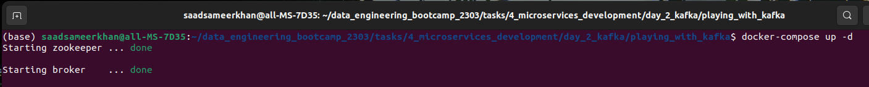
- Creating a new topic with the name ‘new_topic’ with the broker. container in the docker-compose to be used as the bootstrap server.
- Listing all created/running topics.
- Inspecting the topics “new_topic” and “events” (created earlier) to view their number of partitions. We see that both topics have a single partition having an ID 1.

